AMIT MALVIYA 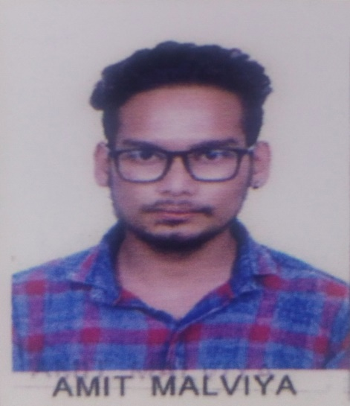
CONTACT NUMBER – 7049874058,6263159970
EMAIL - amitmalviya0255@gmail.com
ADDRESS – H.NO 1507 NEAR RAM MANDIR BEHTA GAON BAIRAGARH BHOPAL (M.P.)

CAREER OBJECTIVE :
To work for an organization which provides me the opportunity to improve my skills and knowledge to growth along with the organization objective.

EDUCATION :
YEAR | EDUCATION | SCHOOL/COLLEGE | BOARD/UNIV. | YEAROF PASSING | CGPA/  PERCENT
2018 - 2022 | B.TECH | UNIVERSITY INSTITUTE OF TECHNOLOGY R.G.P.V BHOPAL | RAJEEV GANDHI PROUDYOGIKI VISHWAVIDYALAYA BHOPAL | 2022 | 6.97 CGPA
2018 | 12^th | DEEPMALA PAGARANI SANSKAR PUBLIC SCHOOL BAIRAGARH | M.P. BOARD | 2018 | 61.40%
2016 | 10^th | DEEPMALA PASGARANI SANSKAR PUBLIC SCHOOL BAIRAGARH | M.P. BOARD | 2016 | 73.83%

TECHNICAL SKILLS :
# POWER SYSTEM
# BASIC KNOWLEDGE OF C/C++

TRAINING :

INDUSTRIAL TRAINING
ORGANIZATION : POWER DISTRIBUTION TRAINING CENTRE BHOPAL (PDTC)
DURATION : 1 WEEK
ROLE : AS TRAINEE

PROJECT :
MINOR PROJECT : STRESS METER
MAJOR PROJECT : HEALTH MONITIORING SYSTEM OF TRANSFORMER

PERSONAL SKILLS :
# LEADERSHIP
# CREATIVITY
# CRITICAL THINKING

HOBBIES :
# PLAYING KABBADI
# MUSIC

DECLERATION:
I HEREBY DECLEARE THAT ALL THE INFORMATION PROVIDED BY ME IN THIS APPLICATION IS FACTUAL ANDCORRECT TO THE BEST OF MY KNOWLEDGE AND BELIEF.

